February 2, 2022 | TSX-V: FCO

Fabled hits High Grade gold returning 86.10 g/t Au within 4,821.98 g/t Ag Eq in 21.90 meters Grading 5.29 g/t Au contained within 349.21 g/t Ag Eq

Vancouver, British Columbia – Fabled Silver Gold Corp. (“Fabled” or the “Company”) (TSXV: FCO; OTCQB: FBSGF, and FSE: 7NQ) announces the final results of Phase 1 surface diamond drilling from the upgraded 14,400 -meter drill program on the “Santa Maria” Property in Parral, Mexico.

Peter J. Hawley, CEO and President, remarks, “Planned definition hole SM20-50 was not only designed to fill in a drill poor gap in the past resource area and to follow the down dip mineralized plunge intercepted in drill hole SM20-47, 48 and 49, all of which reported broad zones of silver and gold bearing hydrothermal breccias with numerous higher-grade intercepts within, but also to vector in on the developing high-grade hydrothermal gold domain. See Figure 1 below.
Figure 1 – Longitudinal View of Area of Current Drilling Being Reported

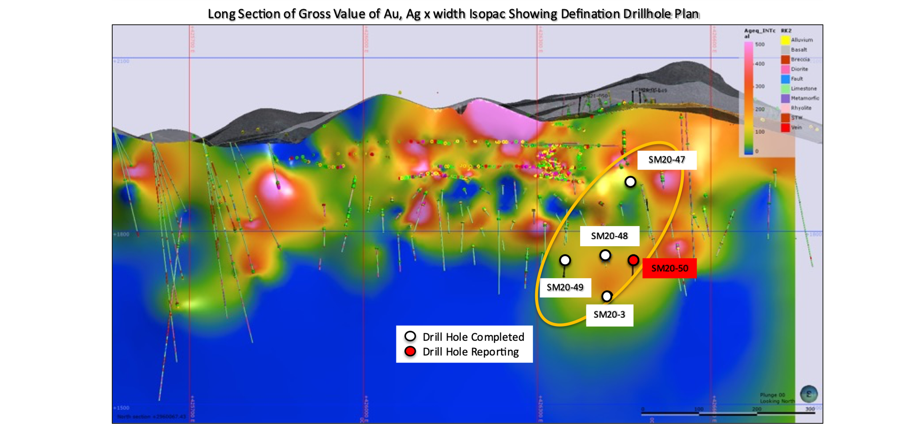

SM20-50

Definition Diamond Drill Hole SM20-50 was drilled at a dip, or angle, of -75 degrees for a planned total drilled length of 294 meters. It was designed to hit the targeted zone at approximately -260 meters below surface.

Before intercepting the main Santa Maria hydrothermal breccia / structure target at depth, the previously newly discovered shallow mineralized hydrothermal breccia was intersected once again from 148.00 – 153.10 meters and graded 131.49 g/t Ag Eq over the 5.10 meters. See Photo 1, Figure 2 and Table 1 below.

Photo 1 – SM20- 50
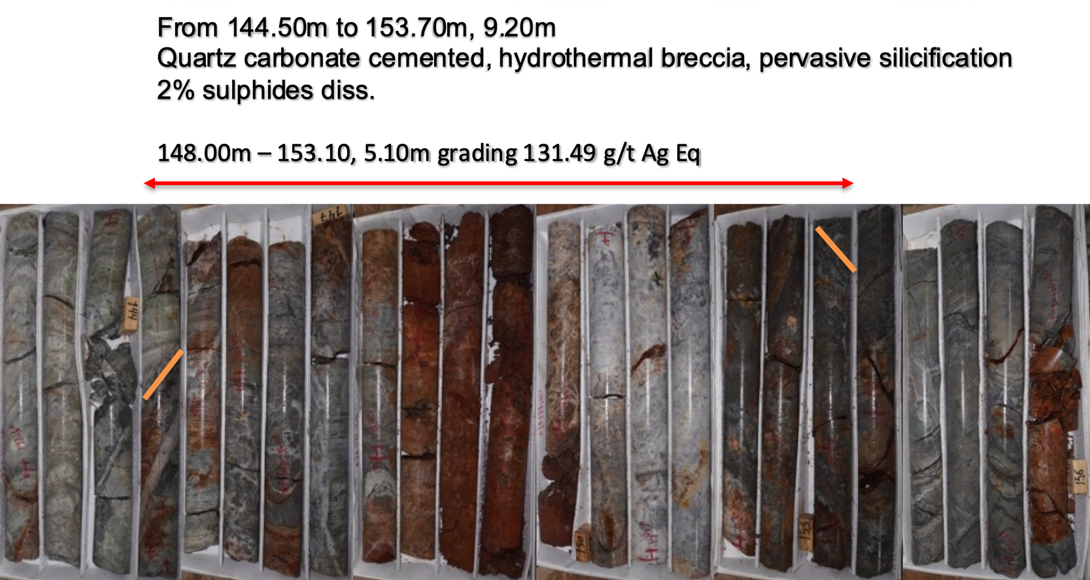

Previously reported holes SM20-47, 48 and 49 all intercepted this new hydrothermal breccia. In this case the hanging wall of the breccia intercepted by hole SM20-50 reported 321.39 g/t Ag Eq with 0.51 g/t Au over 1.25 meters. See photo 2, Figure 2 and Table 1 below.

This new discovery is defining previously unknown silver - gold mineralization which will be added to the data base for the internal resource model.

Photo 2 – SM20 - 50
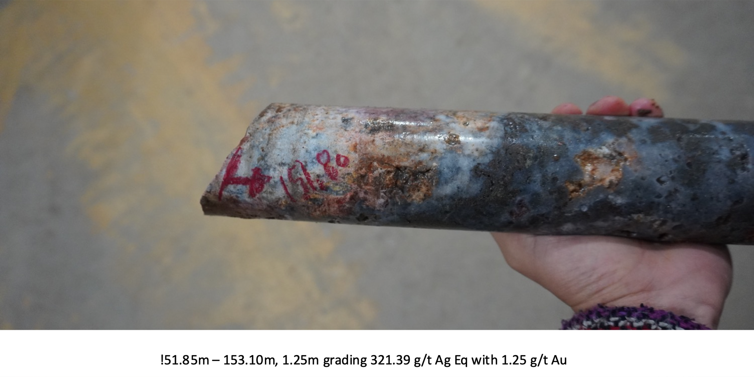
The main target which was the the Santa Maria footwall hydrothermal breccia structure was intercepted from 267.00 – 288.90 meters. The entire 21.90 meters reported 5.29 g/t Au within 349.21 g/t Ag Eq. This gold domain hydrothermal system remains open at depth and on strike. See Figure 2, Table 1, Photo 3, 4 below.

Figure 2 – Cross Section Diamond Drill Hole SM20-50
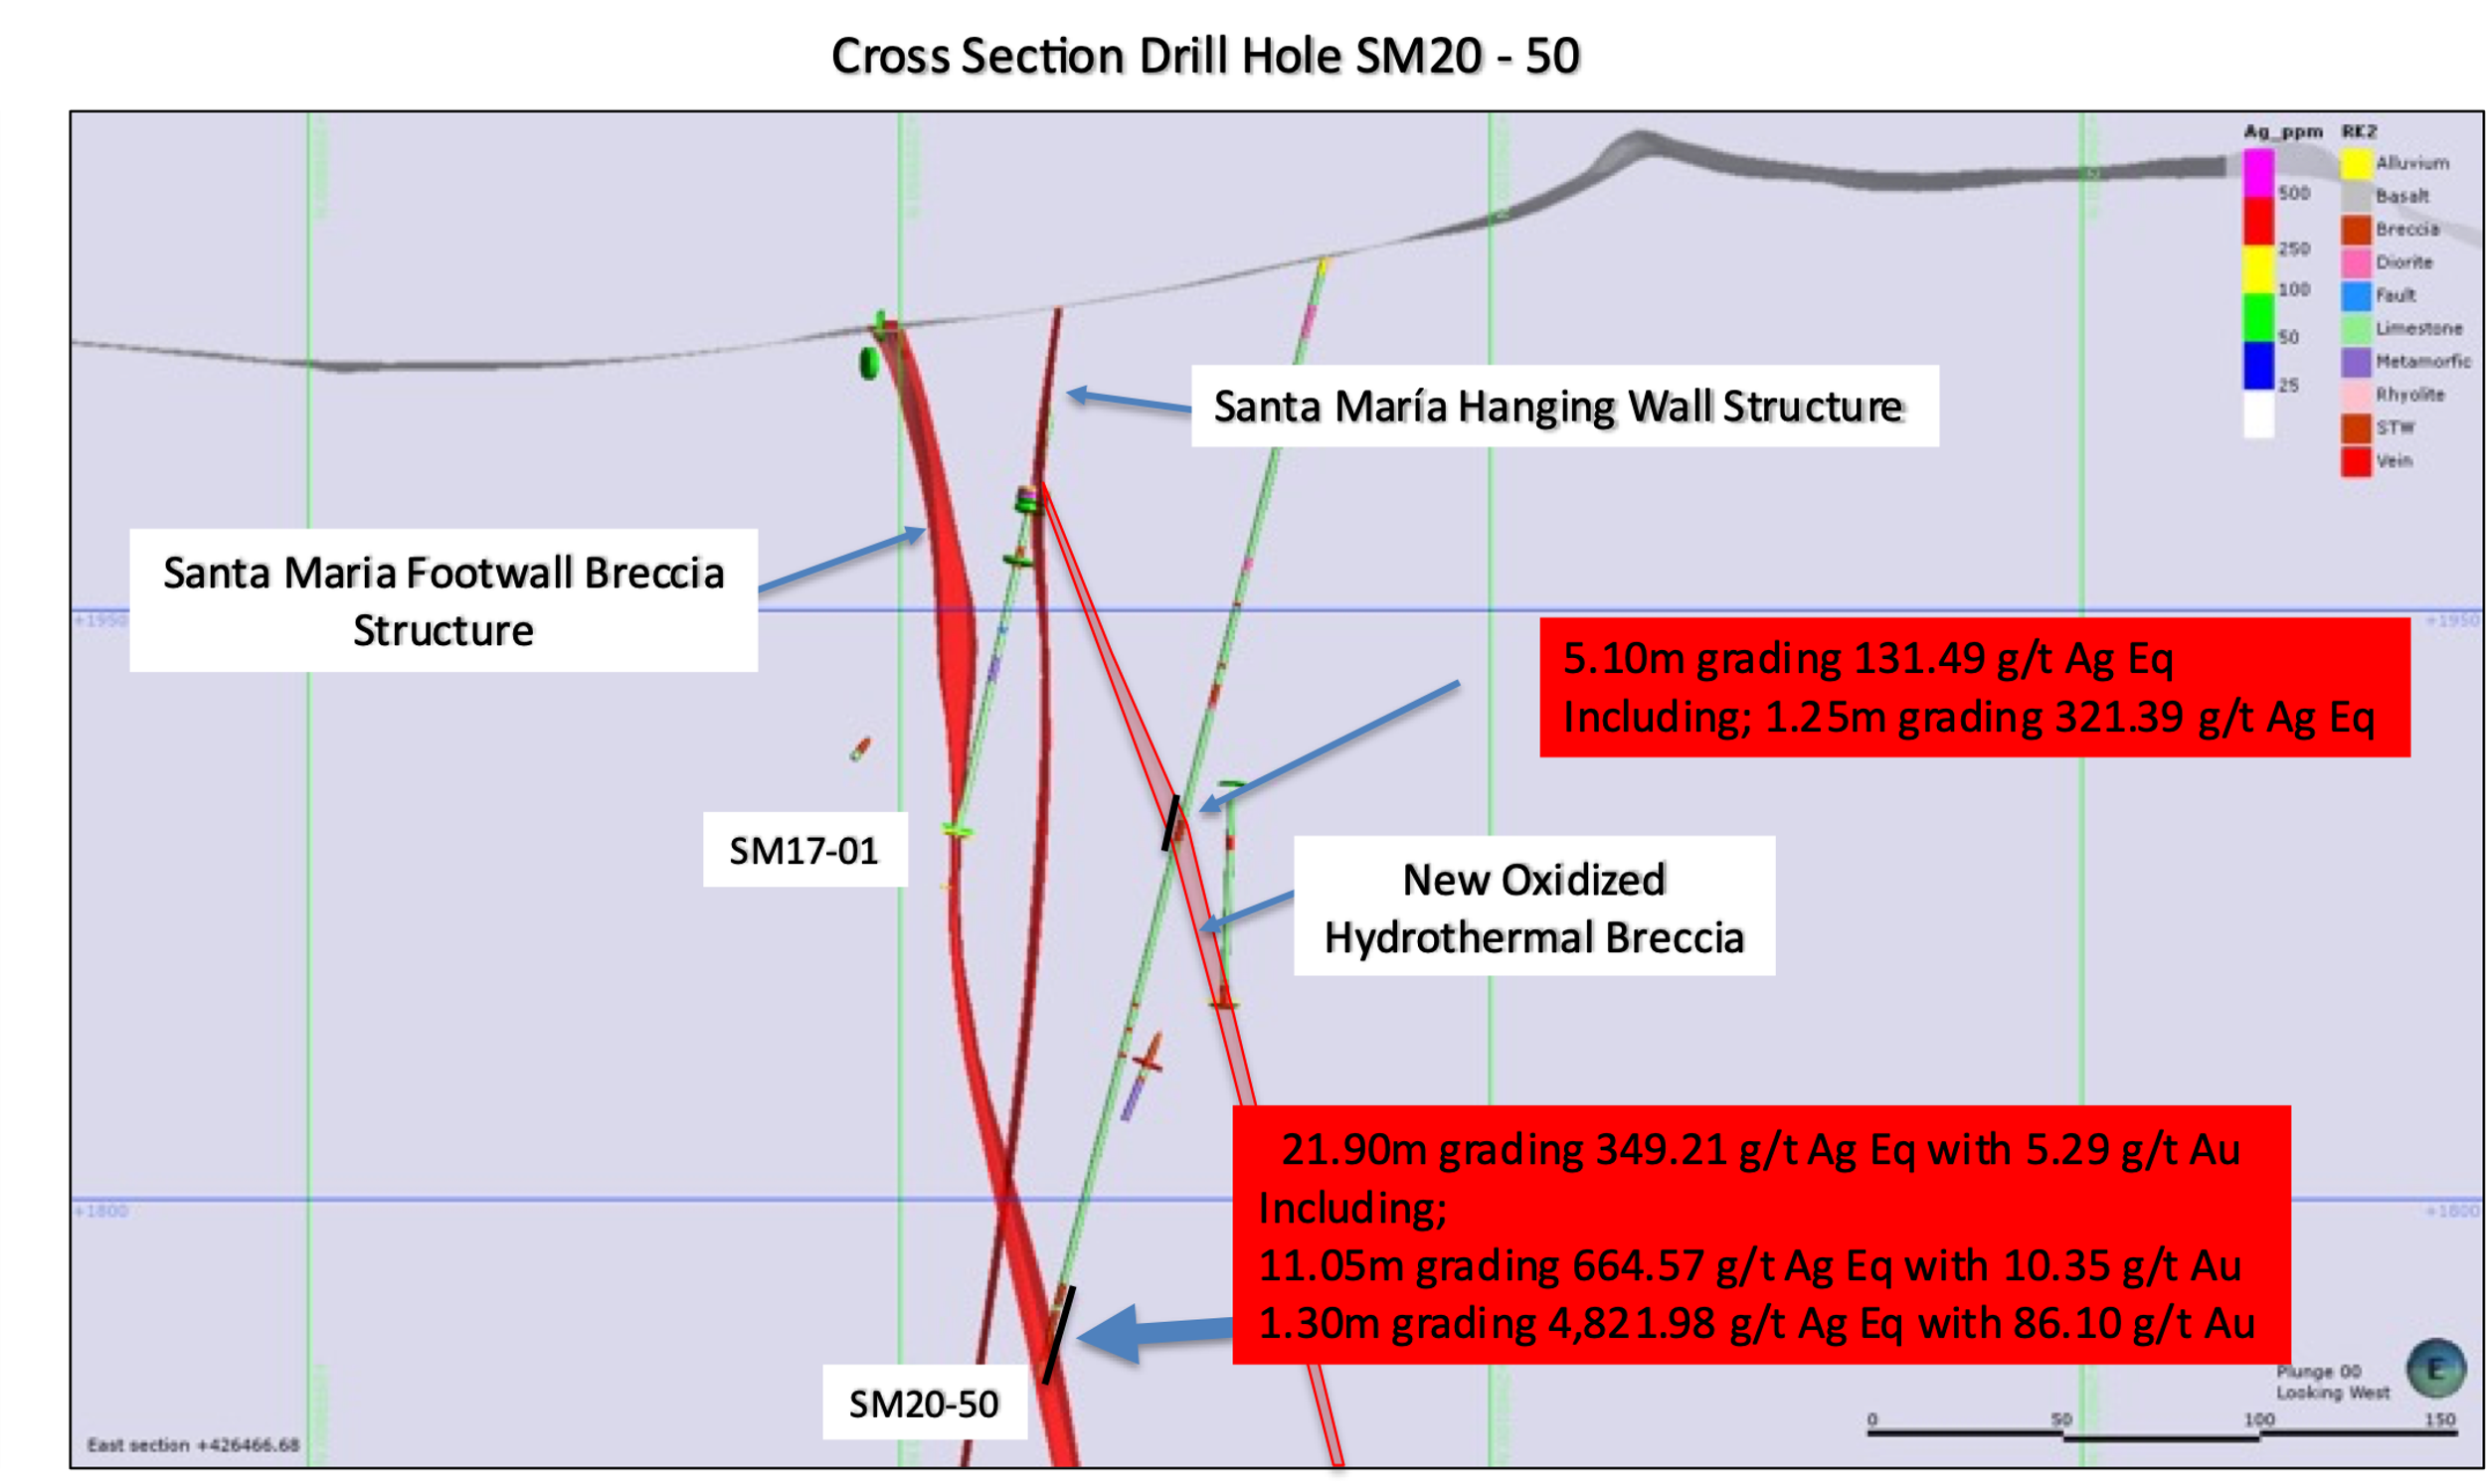

Within the 21.90 meters of gold – silver mineralization, 11.05 meters from 269.60 – 280.65 meters assayed an impressive 11.05 g/t Au within 664.57 g/t Ag Eq. See Figure 2 above, Table 1 and Photos 3, 4 below.

Photo 3 – SM20 - 50
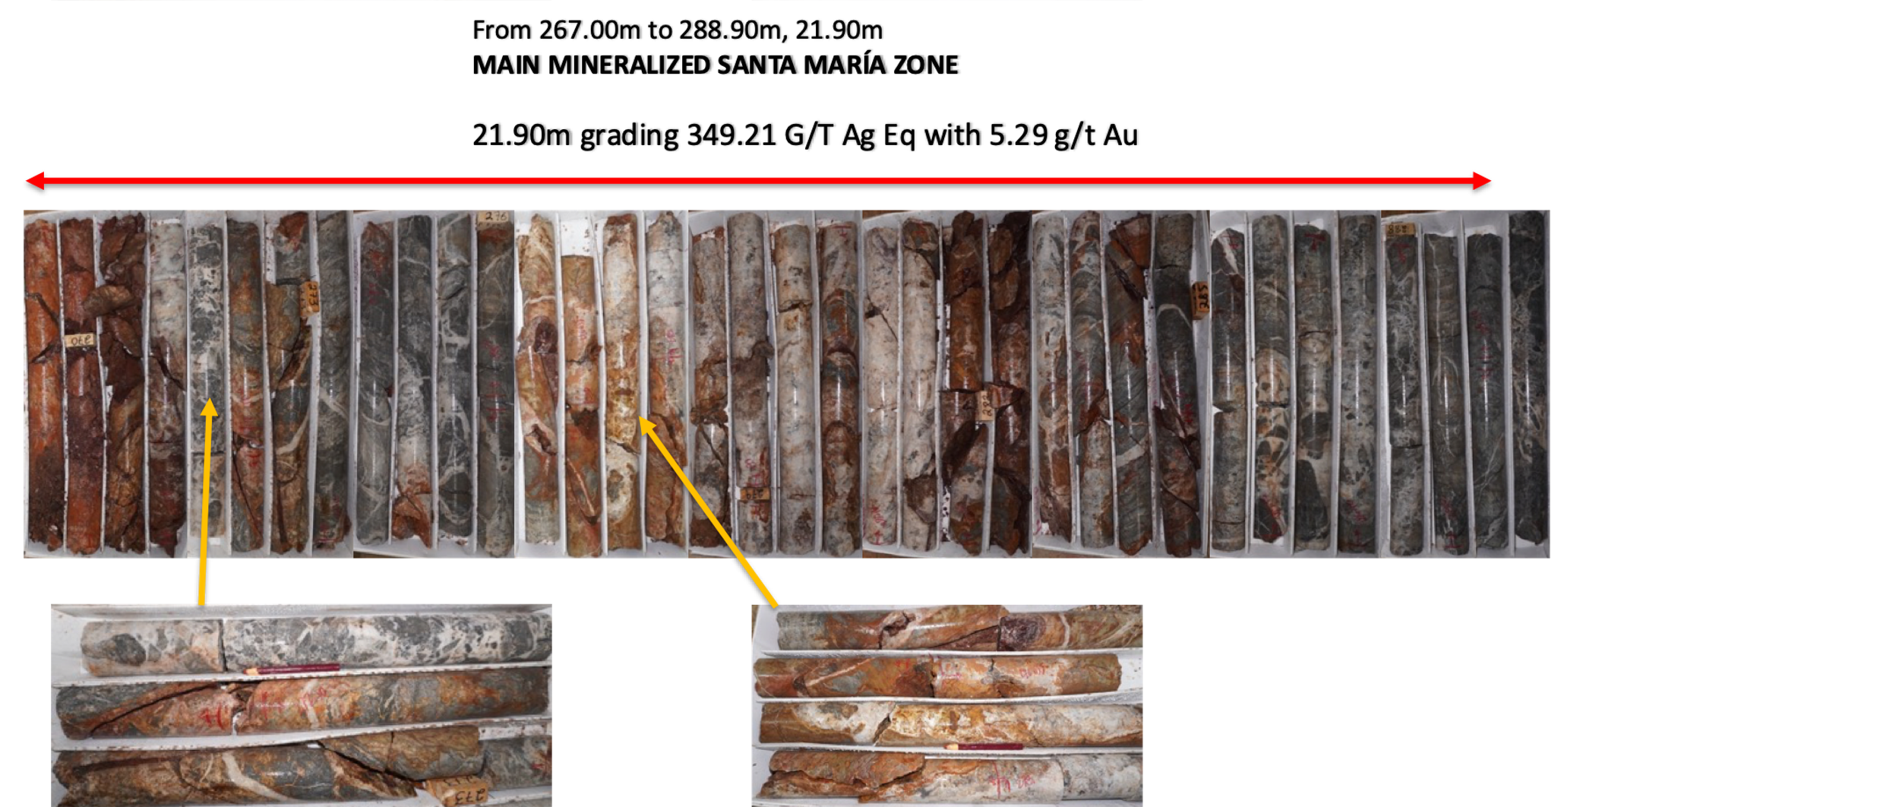

Table 1- SM20-50 Drill Hole Assay Results

Drill Hole | From m | To  m | Width m | Au g/t | Ag g/t | Ag Eq* g/t | Pb % | Zn % | Cu %
SM20-50 | 148.00 | 153.10 | 5.10 | 0.37 | 112.46 | 131.49 | 0.43 | 1.35 | 0.02
Including | 151.85 | 153.10 | 1.25 | 0.51 | 295.00 | 321.39 | 1.19 | 4.37 | 0.05
 | 267.00 | 288.90 | 21.90 | 5.29 | 77.09 | 349.21 | 0.11 | 0.22 | 0.01
Including | 269.60 | 280.65 | 11.05 | 10.35 | 132.17 | 664.57 | 0.17 | 0.30 | 0.02
Including | 270.80 | 272.10 | 1.30 | 86.10 | 393.00 | 4,821.98 | 0.09 | 0.31 | 0.03
- ** Ag Equivalent (“Ag Eq”) grade is calculated using $20 per ounce Ag and $1,600 Au.

Worthy of note is the very high-grade gold intercept from 270.80 – 272.10 meters where assay results returned 86.10 g/t gold within 4,821.98 g/t Ag Eq.
Photo 4 – SM20- 50
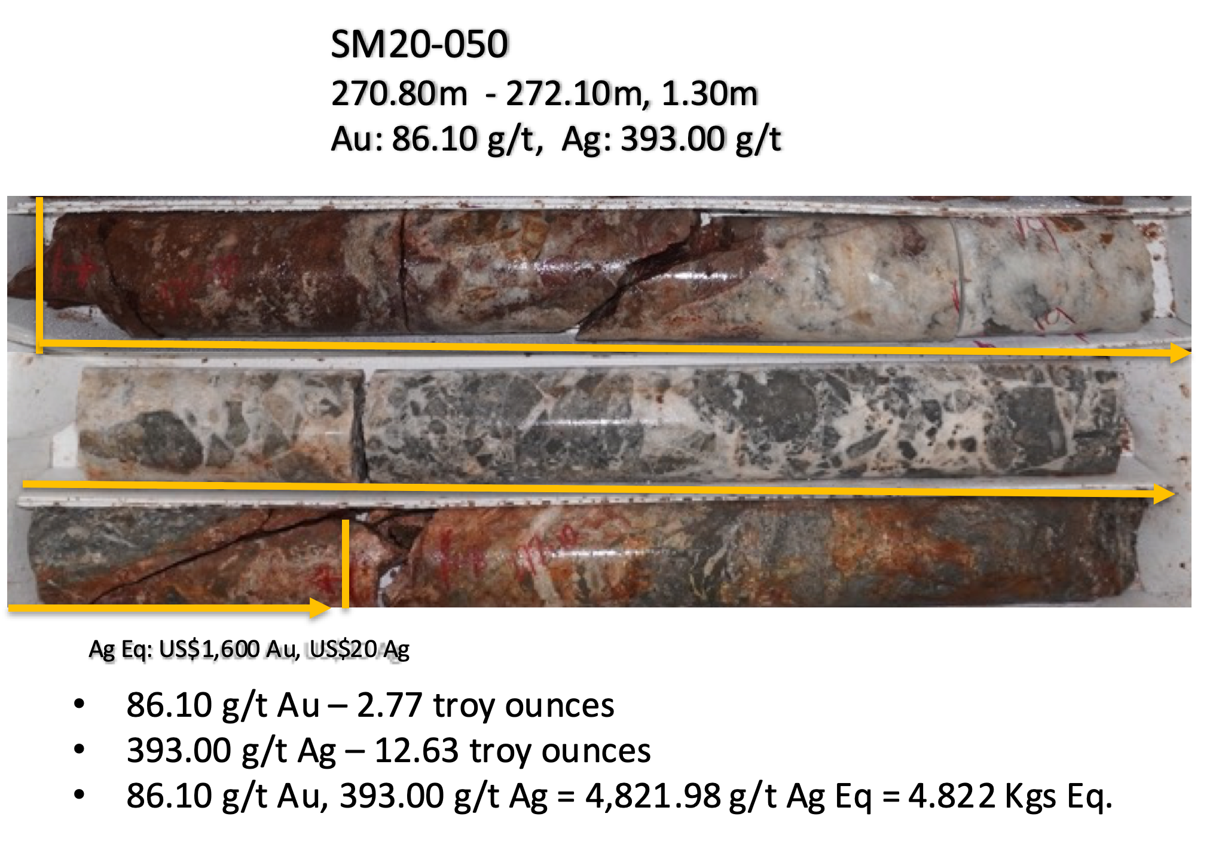
Summary
Hole SM20-50 was extremely successful not only in infill drilling of a drill poor area, but also following the vertical down plunge of the Santa Maria structure by -160 meters from hole SM20-47 and vectoring in on earlier results from holes SM20-48 and 49.

In addition, the new up hole hydrothermal breccia that was intercepted shows that the structure has increased or opened up to 5.10 meters grading 131.49 g/t Ag Eq and contains a higher-grade component of 321.39 g/t Ag Eq with 0.51 g/t Au over 1.25 meters. This new silver – gold mineralized hydrothermal breccia not only remains open in all directions but will add new mineralized ounces to the various systems we have discovered during this first phase of drilling.
In addition to the new breccia, the strong gold bearing domain intercept of the main footwall of the Santa Maria hydrothermal breccia, where the entire 21.90 meters reported 5.29 g/t Au within 349.21 g/t Ag Eq, and the exceptional higher-grade component of 86.10 g/t gold within 4,821.98 g/t Ag Eq not only add quality gold and silver ounces to the resource build out but remain open at strike and depth.
This completes the Phase 1 exploration and definition drilling on the mineralized Santa Maria structures, breccias and diorite dikes. The Company will now compile all the results to define not only follow up definition drilling targets, but to outline targets in the eastern sector of the property. This sector includes newly discovered mineralization outcropping on surface, and also geophysical IP anomalies previously identified, all which have never been drilled.
QA QC Procedure

Analytical results of sampling reported by Fabled Silver Gold represent core samples that have been sawn in half with half of the core sampled and submitted by Fabled Silver Gold staff directly to ALS Chemex, Chihuahua, Chihuahua, Mexico. Samples were crushed, split, and pulverized as per ALS Chemex method PREP-31, then analyzed for ME-ICP61 33 element package by four acid digestion with ICP-AES Finish. ME-GRA21 method for Au and Ag by fire assay and gravimetric finish, 30g nominal sample weight.
Over Limit Methods
For samples triggering precious metal over-limit thresholds of 10 g/t Au or 100 g/t Ag, the following is being used:
Au-GRA21 Au by fire assay and gravimetric finish with 30 g sample.
Ag-GRA21 Ag by fire assay and gravimetric finish.
Fabled Silver Gold monitors QA/QC using commercially sourced standards and locally sourced blank materials inserted within the sample sequence at regular intervals.
About Fabled Silver Gold Corp.

Fabled is focused on acquiring, exploring and operating properties that yield near-term metal production. The Company has an experienced management team with multiple years of involvement in mining and exploration in Mexico. The Company's mandate is to focus on acquiring precious metal properties in Mexico with blue-sky exploration potential.

The Company has entered into an agreement with Golden Minerals Company (NYSE American and TSX: AUMN) to acquire the Santa Maria Property, a high-grade silver-gold property situated in the center of the Mexican epithermal silver-gold belt. The belt has been recognized as a significant metallogenic province, which has reportedly produced more silver than any other equivalent area in the world.

Mr. Peter J. Hawley, President and C.E.O.
Fabled Silver Gold Corp.
Phone: (819) 316-0919
peter@fabledfco.com

For further information please contact:

info@fabledfco.com

The technical information contained in this news release has been approved by Peter J. Hawley, P.Geo. President and C.E.O. of Fabled, who is a Qualified Person as defined in National Instrument 43-101 - Standards of Disclosure for Mineral Projects.

Neither the TSX Venture Exchange nor its Regulations Service Provider (as that term is defined in the policies of the TSX Venture Exchange) does accept responsibility for the adequacy or accuracy of this news release.

Certain statements contained in this news release constitute "forward-looking information" as such term is used in applicable Canadian securities laws. Forward-looking information is based on plans, expectations and estimates of management at the date the information is provided and is subject to certain factors and assumptions, including, that the Company's financial condition and development plans do not change as a result of unforeseen events and that the Company obtains any required regulatory approvals.

Forward-looking information is subject to a variety of risks and uncertainties and other factors that could cause plans, estimates and actual results to vary materially from those projected in such forward-looking information. Some of the risks and other factors that could cause results to differ materially from those expressed in the forward-looking statements include, but are not limited to: impacts from the coronavirus or other epidemics, general economic conditions in Canada, the United States and globally; industry conditions, including fluctuations in commodity prices; governmental regulation of the mining industry, including environmental regulation; geological, technical and drilling problems; unanticipated operating events; competition for and/or inability to retain drilling rigs and other services; the availability of capital
on acceptable terms; the need to obtain required approvals from regulatory authorities; stock market volatility; volatility in market prices for commodities; liabilities inherent in mining operations; changes in tax laws and incentive programs relating to the mining industry; as well as the other risks and uncertainties applicable to the Company as set forth in the Company's continuous disclosure filings filed under the Company's profile at www.sedar.com. The Company undertakes no obligation to update these forward-looking statements, other than as required by applicable law.

